Magnetic characterisation of greigite: methods and interpretation
Prepared by N. Anderson for Nagashima, Wang, Anderson, Ayala-Garnica, Kirschvink and Ozturk, “Greigite–Vivianite Prebiotic Geochemistry & Ribonucleotide Homochirality”
Draft, 6 October 2026 · covers only runs documented in Greigite Thin Film magnetometry documentation.xlsx

1. Why magnetic measurements bear on the homochirality argument
The model requires that D-ribose-aminooxazoline (D-RAO) crystallise preferentially on a greigite surface through the chiral-induced spin selectivity (CISS) effect. CISS requires the surface to present spin-polarised electrons, and that in turn requires the greigite to carry a magnetisation which is present with no applied field, spatially coherent over the area a nucleating molecule samples, and stable for the duration of the crystallisation experiment.
Those three requirements are remanence, domain state and thermal stability — which are the three quantities rock magnetism exists to measure. The magnetic work reported here is therefore not a mineralogical afterthought appended to the chemistry. It tests directly whether the synthesised material can do what the model asks of it. Three conditions have to hold:
- The phase must be ferrimagnetic greigite. Mackinawite, the precursor, is antiferromagnetic and carries essentially no remanence; magnetite and pyrrhotite are ferrimagnetic but have different surface chemistry, and magnetite in particular is the substrate greigite is proposed to replace.
- The particles must be single domain. A single-domain (SD) particle carries a uniform moment across its whole volume, so its surface presents one spin direction. A larger particle breaks into domains whose surface fields largely cancel, and a vortex state closes the flux internally; in either case the net surface polarisation collapses, and with it the spin selectivity the model depends on.
- The moment must be blocked at room temperature. A particle below the superparamagnetic threshold reverses spontaneously on a timescale of seconds and presents no fixed spin direction at all, however ferrimagnetic the mineral is.
A hysteresis loop returns assemblage averages and cannot separate these conditions: a mixture of superparamagnetic and multidomain grains can return the same M_{rs}/M_{s} as a uniform single-domain population. A first-order reversal curve (FORC) diagram returns the distribution rather than the average, and can.

2. Instruments
2G Enterprises cryogenic SQUID magnetometer (Caltech). A superconducting quantum interference device (SQUID) magnetometer with an automated sample-changer system, carrying in-line alternating-field (AF) demagnetisation coils, an in-line anhysteretic remanent magnetisation (ARM) bias coil, in-line direct-field coils and a pulse magnetiser. Because every component lies in line with the sample track, a full suite of remanence experiments runs unattended on one specimen without it leaving the track. Fields are applied at one station and the specimen is then transported to a magnetically shielded sensing region, where the moment is measured in near-zero field. The instrument therefore measures remanence only: in-field measurement is not merely inconvenient on this geometry, it is structurally impossible. Moment resolution is of order 3 × 10⁻¹² Am² and the instrument accepts a standard specimen of about 10 cm³.
Princeton MicroMag 2900/3900 vibrating-sample magnetometer (Kochi Core Center, Japan). In-field measurement: hysteresis loops and first-order reversal curves. Operated at 83 Hz with a 200 ms averaging time and a 20 µAm² moment range, recording field in tesla and moment in Am². The GGTF v3 thin film and a bare fluorine-doped tin oxide (FTO) substrate blank were measured here.
Quantum Design MPMS3 (Kochi Core Center). A Magnetic Property Measurement System (MPMS) — a SQUID magnetometer built around a cryostat rather than a sample track. Low-temperature remanence from 5 to 300 K, used for mineral identification by the presence or absence of magnetic phase transitions.

3. Run types, what each contains, and what each yields
The laboratory logs every measurement under one of a small number of run types, and it is worth being explicit about them, because the names are used loosely in the literature and because each type is a composite of several distinct experiments rather than a single measurement. The 2G produces three (rock magnetic routine, remFORC, and rotational remanent magnetisation or RRM); the Kochi instruments produce three more (in-field FORC, hysteresis and low-temperature).
Two remanence abbreviations recur throughout and are worth fixing here: IRM for an isothermal remanent magnetisation, one imparted by a steady field pulse at room temperature, and SIRM for its saturated form, the largest such remanence the specimen will hold. Appendix A lists every abbreviation and symbol used in this document.

3.1 Rock magnetic routine — “Rock Mag”, file .cor.rmg (2G)
The workhorse run: a single composite sequence of remanence experiments carried out unattended on one specimen without it leaving the sample track, each remanence imparted onto an AF-cleaned state so the experiments do not contaminate one another. In order, it contains:
- Measurement of the natural remanent magnetisation (NRM), then stepwise AF demagnetisation of it. → The remanence the specimen arrived with, and how firmly it is held. For synthetic material this is mostly a check that the specimen and holder are clean.
- ARM acquisition in 11 steps, at a 100 mT peak alternating field with the steady bias raised from 0 to 1 mT. → The ARM susceptibility χ_{ARM} as a fitted slope, and ARM/SIRM — the grain-size proxy, because fine single-domain grains acquire ARM efficiently and coarse multidomain grains do not.
- AF demagnetisation of that ARM. → The median destructive field of the ARM (MDF_{ARM}), which measures how firmly that remanence is held.
- An IRM imparted in a 100 mT pulse, then AF demagnetised over the same field steps. → The Lowrie–Fuller pair: comparing the AF decay of an ARM against that of an IRM of matched magnitude tests the internal consistency of the remanence carriers.
- Stepwise IRM acquisition in 20–35 logarithmically spaced pulses to 973 mT. → The saturation remanence SIRM; the switching-field distribution as the derivative with respect to log field, summarised by its median and dispersion; and the S-ratio at 300 mT, which measures what fraction of the remanence is carried by a low-coercivity phase.
- AF demagnetisation of the saturation IRM in 20 steps to 400 mT. → MDF_{IRM}; and, crossed against the acquisition curve, the remanent coercivity B_{cr} and the Wohlfarth–Cisowski R parameter.
A complete routine occupies 2.3 to 5.5 h depending on the number of steps. Nearly every number in the specimen table comes from this one run type.

3.2 FORC — in field, files .forc.00n (VSM)
The conventional first-order reversal curve experiment. The specimen is saturated, taken to a reversal field H_{r}, then the field is swept upward through a series of values H_{b} with the moment recorded continuously — crucially, while the field is applied. Repeating for progressively more negative H_{r} fills the surface from which the FORC distribution is computed. → ρ(B_{c}, B_{u}) including the reversible component; and, because the curves pass through zero field, a backfield remanence curve can be recovered from them.
Here: a 500 mT saturating field, reversal fields from 0 to 250 mT in B_{c} and −100 to +100 mT in B_{u}, a 3.06 mT increment, 160 reversal curves per run and four runs stacked. Run on the thin film only.

3.3 remFORC — remanence FORC, file .frc.rmg (2G)
The same reversal-curve sequence, but on an instrument that applies the field at one station and measures at another. Every point is therefore a remanence recorded in near-zero field after the specimen has been transported, not an in-field moment. → ρ(B_{c}, B_{u}) over the blocked, switchable population only, the reversible and superparamagnetic fractions being absent by construction; plus, at no extra measurement cost, the direct-current demagnetisation (DCD) backfield curve, because the locus of the reversal points is itself a backfield curve. That in turn gives B_{cr} and the remanence coercivity spectrum.
Here: a 500 mT saturating pulse, reversal fields stepped from −2.5 to −150 mT (−200 mT for the sulfur-rich powder and the hydrothermal benchmark), 20 to 35 reversal curves and 520 to 1050 measured points. A single run occupies 12 to 24 h, dominated not by the SQUID measurement but by the transport cycle, which is repeated once per measured point. Run on the five powders; the thin film’s remFORC is pending. Section 4 sets out what the distribution means and why the remanence variant suits this problem.

3.4 RRM — rotational remanent magnetisation, file .cor.rmg with RRM steps (2G)
The specimen is rotated about the axis of an alternating field during demagnetisation, and the moment acquired along the rotation axis is measured. → The sign of the moment against the sense of rotation, which is the diagnostic; and its dependence on rotation rate. A remanence that reverses when the rotation reverses is the Stephenson effect and cannot be produced by any axial experiment, so it is not confusable with a stray ARM.
Here: a 94 mT peak alternating field, with two coarse sweeps covering ±40 revolutions per second and two fine sweeps covering ±1 and ±3. Run on the thin film only. Its value is mineralogical: greigite carries by a wide margin the largest gyromagnetic effect of any mineral surveyed (Hu, Stephenson and Appel 2002), so a strong sign-reversing RRM is close to a fingerprint for it.

3.5 Hysteresis — file .hys (VSM)
A major loop swept to ±1 T, measured in field. → Saturation magnetisation M_{s}, saturation remanence M_{rs}, coercivity B_{c}, the ratio M_{rs}/M_{s} (0.5 for randomly oriented non-interacting uniaxial single-domain particles, falling towards 0.05 and below for multidomain material), and the high-field paramagnetic slope. M_{s} and B_{c} are in-field quantities and cannot be obtained from the 2G at all, which is why this run exists.
The high-field slope must be fitted on each polarity separately and the two slopes averaged. Fitting both tails in one regression returns the slope of the line joining +M_{s} to −M_{s} — the loop itself — and subtracting it erases the ferromagnetic signal: done that way these specimens return an M_{s} two orders of magnitude too small and a coercivity of 860 mT.

3.6 Low-temperature — file .dat (MPMS)
Moment recorded on warming from 5 to 300 K in zero field. → The presence or absence of mineral-diagnostic phase transitions, and the shape of the remanence loss, which is itself domain-state sensitive. Here 257 retained points, with four isolated instrument dropouts near 105 K rejected against the local median step — necessary because one bad point produces a spike in the derivative indistinguishable from a real transition.

3.7 Which specimens have which runs
The coverage is uneven, and the gaps constrain what can be said. The powders carry the FORC-based results; the thin film carries the mineral identification and the hysteresis.
Specimen | Rock Mag | remFORC | FORC (in field) | RRM | Hysteresis | Low-T
Mackinawite control | FeS_0.cor | FeS_0.frc | — | — | — | —
Greigite, sulfur rich | FeS.cor | FeS.frc | — | — | — | —
Greigite, iron rich | FeS_Fe.cor | FeS_Fe.frc | — | — | — | —
Greigite, UV route | FeS_UV.cor | FeS_UV.frc | — | — | — | —
Greigite, hydrothermal | Greg001.cor | Greg002.frc | — | — | — | —
Thin film GGTF v3 | ggtf_RM ×2 | pending | Kochi ×2 | ×4 | Kochi ×2 | Kochi
Two consequences. The thin film — the material the model is built around — has no remFORC, so every statement about its FORC distribution rests on the in-field Kochi measurement rather than on the remanence variant. And the five powders have no hysteresis, so M_{s} and M_{rs}/M_{s} are unavailable for them and no powder can be placed on a Day diagram.

4. What a FORC diagram actually measures
A FORC experiment saturates the specimen, applies a reversal field H_{r}, then sweeps the field upward through a series of values H_{b}, recording the magnetisation at each. Repeating for progressively more negative H_{r} fills a surface M(H_{r}, H_{b}), and the FORC distribution is its mixed second derivative,
ρ(B_{c}, B_{u}) = −½ ∂²M / ∂H_{r} ∂H_{b}, with B_{c} = (H_{b} − H_{r})/2 and B_{u} = (H_{b} + H_{r})/2,
estimated here by local second-order polynomial regression (Pike, Roberts and Verosub 1999; Roberts, Pike and Verosub 2000).
The physical content is clearest through the hysteron picture. Model the assemblage as a population of elementary rectangular loops, each with its own switching field B_{c}, and each displaced along the field axis by a local bias field B_{u}. The FORC distribution is then the joint distribution of those two quantities over the population, and the two axes mean different physical things:
The B_{c} axis is an energy-barrier axis. A particle’s switching field is set by its volume, its shape and its magnetocrystalline anisotropy. High B_{c} means a deep energy barrier and a magnetisation that resists reversal, so the spread along B_{c} is the spread of thermal stabilities in the assemblage. This is where the blocked/superparamagnetic distinction lives.
The B_{u} axis is an interaction axis. The bias field a particle experiences is the vector sum of the stray fields of its neighbours. In a dilute assemblage every particle sees approximately zero and the distribution is a narrow horizontal band; as packing density rises, the spread in B_{u} grows in proportion to the strength of the magnetostatic coupling.
That second axis is why a FORC is worth the instrument time for this problem, and it is not available from a hysteresis loop at all. Whether a greigite film presents a coherent spin-polarised surface depends on whether its particles behave as independent magnets or as a strongly coupled array, and the width of ρ in B_{u} measures exactly that.
Two further readings follow from the shape. A single-domain assemblage gives a closed peak at finite B_{c}. Vortex and multidomain particles instead give density concentrated against the B_{c} = 0 axis and diverging vertically, the signature of domain walls moving reversibly rather than moments switching irreversibly. And particles small enough to reverse spontaneously contribute nothing at all to a remanence-based distribution, so the superparamagnetic fraction is excluded automatically rather than having to be modelled out.

4.1 Remanence FORC on a cryogenic magnetometer
Because the 2G measures in near-zero field after transport, every point on every reversal curve is a remanence, and the resulting object is a remanence FORC (remFORC). It differs from an in-field FORC in a way that happens to suit this application. The reversible component of magnetisation — the part that follows the applied field and vanishes when the field is removed — is absent by construction. Since the reversible and superparamagnetic fractions are precisely the fractions that cannot hold a surface magnetisation once the field is off, a remFORC images only the blocked, switchable population: the fraction that could template chirality.
The remanence route to a Preisach or FORC distribution is not new. Carvallo, Dunlop and Özdemir (2005) measured the same sequence, compared it directly against in-field FORC, and found good agreement in the position of the distribution peak. They nonetheless advised against it, on the grounds that it yielded a few hundred measured points where an in-field FORC yielded several thousand, and took about four hours of attended instrument time per specimen. Those objections are properties of a 200 mg alternating-gradient magnetometer. An automated cryogenic magnetometer taking a specimen two orders of magnitude larger runs unattended and produced 520 to 1050 measured points per run here. The term remanent FORC has separately been used by Zhao et al. (2017) for a different construction, in which an in-field FORC is augmented by a remanence measurement after each step; that protocol requires in-field detection and is not what is reported here.

5. Specimens
Six specimens, comprising the mackinawite precursor as a control, three greigite powders made by different routes, a non-prebiotic hydrothermal greigite as a benchmark, and the thin film the model is built around.
Specimen | Synthesis | B_{cr} (mT) | R | ARM/SIRM | Runs
Mackinawite powder (control) | FeCl₂ + NaS₂ | 30.0 | 0.443 | 0.0399 | FeS_0.frc, .cor
Greigite powder, sulfur rich | Fe:S 2:3, pH 5, 80 °C | 69.6 | 0.345 | 0.0072 | FeS.frc, .cor
Greigite powder, iron rich | Fe:S 3:2, pH 5, 80 °C | 38.3 | 0.358 | 0.0156 | FeS_Fe.frc, .cor
Greigite powder, UV route | Fe:S 3:2, pH 8.5, UV, 80 °C | 40.9 | 0.426 | 0.0245 | FeS_UV.frc, .cor
Greigite powder, hydrothermal | ~165 °C, non-prebiotic | 51.9 | 0.243 | 0.0062 | Greg002.frc, Greg001.cor
Greigite thin film, GGTF v3 | on FTO glass | 44.5 | 0.259 | 0.0053 | ggtf_RM.cor, ggtf_RM2.cor, 4 RRM
B_{cr} is from the remFORC reversal branch except for the thin film, where it is the acquisition/demagnetisation crossover (the film has no remFORC). R is the Wohlfarth–Cisowski parameter and ARM/SIRM is evaluated at a 100 µT bias field from the fitted ARM slope. The hydrothermal benchmark is logged with the FORC on one specimen and the rock magnetic routine on another from the same batch; the two agree on B_{cr} to 0.2 %.
Specimen masses are not recorded in the data files, so absolute moments (SIRM, M_{s}, M_{rs}) are not comparable between specimens and no concentration can be inferred from them. Every cross-specimen comparison in this document uses ratios — ARM/SIRM, R, M_{rs}/M_{s} — or coercivities, all of which are independent of how much material was in the holder.

6. Results

6.1 The material is greigite
Three independent lines agree. The hysteresis loops of the thin film give M_{s} = 8.73 and 8.70 µAm², M_{rs} = 3.33 and 3.28 µAm² and B_{c} = 18.91 and 18.89 mT across two preparations, so M_{rs}/M_{s} = 0.381 and 0.377 — within 1 % of each other and within 0.2 % of the values the instrument reports for itself (Fig. 2). The substrate blank carries a linear paramagnetic slope and no detectable hysteresis, so the signal is the film.
The zero-field warming curve is smooth and monotonic from 5 to 300 K, losing 22.9 % of its initial moment, with no step at 120 K and none at 34 K (Fig. 3). Neither magnetite nor monoclinic pyrrhotite is present in quantity, and the absence of any transition is what greigite is expected to show.
The rotational remanence reverses sign with the sense of rotation and does so symmetrically, averaging +5.06 and −4.53 nAm² over the two senses, with two independent runs superimposing (Fig. 4). At its largest the RRM reaches 0.31 to 0.37 of the ARM acquired in a 100 µT bias field. An effect of that size is itself close to diagnostic of greigite.

6.2 The mackinawite control is not magnetically blank
The control is described as a preparation that should carry little or no magnetisation. It does not behave that way. It has an S-ratio at 300 mT of 1.008, so essentially all of its remanence is carried by a low-coercivity ferrimagnetic phase; a remanent coercivity of 30.0 mT and a dispersion of 0.283, both squarely in the range the greigite powders occupy; and the highest ARM/SIRM in the whole set at 0.0399 (Fig. 5). Its FORC distribution (Fig. 1a) is a closed single-domain peak, not the featureless result a non-magnetic preparation would give.
Mackinawite is antiferromagnetic and should carry no appreciable remanence, so a ferrimagnetic phase is present in the control. Its coercivity spectrum resembles the greigite powders, which points to greigite having formed without the intended trigger. All of these quantities are ratios or coercivities, so the conclusion does not depend on the missing specimen masses. This bears directly on how the synthesis experiments are interpreted and is worth chemical follow-up.

6.3 The three syntheses rank consistently, and the UV route ranks best
Two mass-independent measures sensitive to different physics — ARM/SIRM, which responds to grain size, and R, which responds to magnetostatic interaction — order the specimens almost identically (Fig. 5). Reading from fine and weakly interacting to coarse and strongly interacting: mackinawite control (0.0399, R = 0.443), UV route (0.0245, 0.426), iron rich (0.0156, 0.358), sulfur rich (0.0072, 0.345), hydrothermal benchmark (0.0062, 0.243), thin film (0.0053, 0.259).
Of the three prebiotically relevant routes, the UV preparation produces the finest and least interacting greigite, and the non-prebiotic hydrothermal benchmark the coarsest and most strongly interacting. Two independent measures agreeing on the ordering makes it a property of the materials rather than of either reduction. For the model this is a favourable result: the route that is prebiotically plausible is also the one that yields the magnetically most suitable substrate.
Every specimen has R below 0.5, so magnetostatic interaction is present throughout and no preparation behaves as a non-interacting single-domain assemblage.

6.4 Domain state, and what it means for the CISS argument
All six FORC distributions (Fig. 1) show a closed peak at finite B_{c} rather than density diverging along the B_{c} = 0 axis. The assemblages are dominated by particles that switch irreversibly — single-domain or close to it — rather than by domain walls moving reversibly. On the first of the three conditions in Section 1, the material qualifies.
M_{rs}/M_{s} = 0.379 for the film sits below the 0.5 expected of randomly oriented non-interacting uniaxial single-domain particles but far above multidomain values, which is the behaviour of interacting single-domain material and is consistent with R = 0.259. The progressive 23 % loss of remanence on warming points the same way: single-domain greigite loses very little remanence on warming, whereas larger pseudo-single-domain and multidomain particles lose it progressively through domain-wall unpinning (Chang et al. 2009).
The vertical spread of the distributions quantifies the interaction. It is widest for the hydrothermal benchmark and the film, and narrowest for the control and the UV route, in the same order the R parameter gives. For the model this is the consequential measurement: a densely packed, strongly interacting array has neighbouring moments biasing one another, which is what degrades the coherence of the surface spin texture a nucleating molecule samples. Weaker interaction is preferable, and the UV route delivers it.

6.5 The thin film
The film sits at the coarse, strongly interacting end of the set on both measures (ARM/SIRM = 0.0053, R = 0.259). Some of that is geometric rather than a property of the greigite: a dense two-dimensional array packs particles closer than a dispersed powder and should show stronger magnetostatic coupling for the same particle size. The two rock magnetic runs reproduce each other to four significant figures, so the measurement itself is not in question.
Three instruments agree on how much magnetic material is present, which is the precondition for combining them: the MPMS gives a 5 K remanence of 3.06 µAm², the vibrating-sample magnetometer a room-temperature M_{rs} of 3.33 µAm², and the cryogenic magnetometer a room-temperature SIRM of 4.01 µAm². These are three measurements in two laboratories on instruments of entirely different design, spanning a factor of 1.3.
The film is the one specimen with no remFORC. Its only FORC is the in-field VSM measurement from Kochi (Fig. 1f), and the run intended to supply the remanence version is logged as pending. Until it exists, the FORC statements above rest on the five powders, and the film is characterised by its rock magnetic parameters and its hysteresis loop.

7. Limitations and open items
- Specimen masses are not recorded, so absolute moments cannot be compared between specimens and no concentration can be inferred. Recording masses at the time of mounting would remove this limitation for all future runs at no cost.
- The thin film and the Kochi measurements disagree on remanent coercivity by 58 %: the cryogenic magnetometer gives 44.5 mT from the acquisition/demagnetisation crossover, while the backfield curve recovered from the Kochi in-field FORC gives 28.1 mT, on what is the same physical specimen. Construction choice accounts for about 4 of those 58 points — on the five powders the two constructions agree to between 1.6 and 4.6 %. The most likely cause is that the two are not the same quantity: the in-field value is the moment at zero field during a continuous sweep and still contains magnetisation that has not relaxed, whereas the cryogenic value is a true remanence measured seconds later after transport. Greigite is the most magnetically viscous mineral in common study, so a large difference of this kind is what it should show. Running the pending remFORC on the film resolves it directly, by giving a backfield curve on the same specimen by the same construction.
- No magnetite comparison is included. The argument of the paper is that greigite should replace magnetite as the templating substrate, so a matched magnetite thin film measured under the same protocols would strengthen it considerably. One exists in the data directory but is not in the documentation and has not been included here.
- The ferrimagnetic phase in the mackinawite control should be identified chemically. The magnetic data establish that it is there and that it resembles the greigite powders, but cannot by themselves confirm what it is.
- Blocking temperatures and the superparamagnetic fraction have not been measured. The third condition in Section 1 — that the moment is blocked on the timescale of the crystallisation experiment — is supported indirectly by the FORC geometry but has not been tested directly. Low-temperature cycling or frequency-dependent susceptibility would do it.

Figures
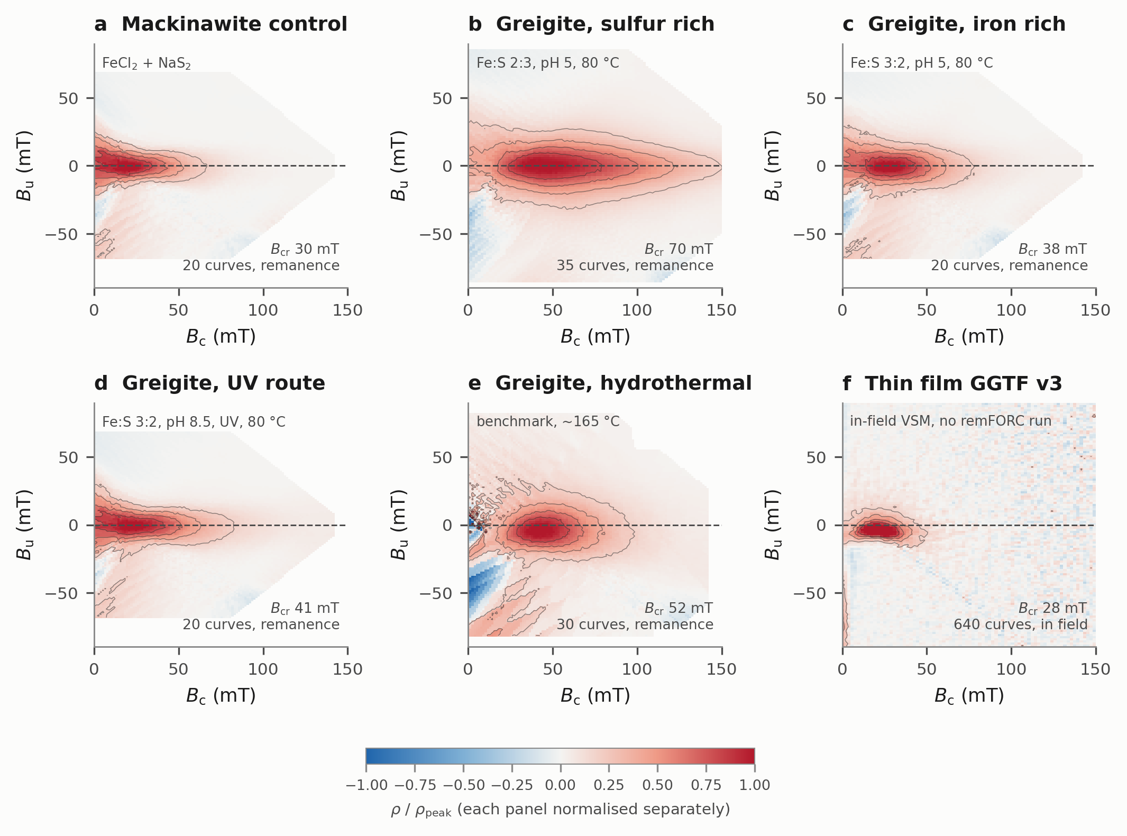
Figure 1. FORC distributions for the six specimens. Panels a–e are remanence FORCs measured on the cryogenic magnetometer; panel f is the in-field FORC of the thin film measured at Kochi, because no remanence FORC of the film has been run. Each panel is normalised to its own peak, the specimens spanning three orders of magnitude in moment. Contours are at 0.2, 0.4, 0.6 and 0.8 of the peak. Every panel shows a closed peak at finite B_{c} rather than density diverging along B_{c} = 0, which is single-domain rather than multidomain behaviour.
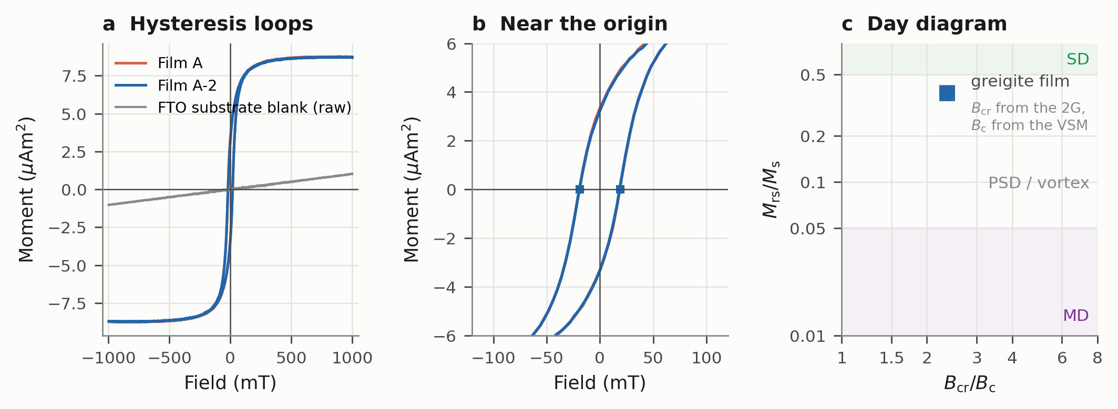
Figure 2. Hysteresis of the thin film, measured at Kochi. (a) Loops for the two preparations after the polarity-separated slope correction, with the bare FTO substrate blank shown uncorrected. (b) The same loops near the origin; markers show the zero crossings that define B_{c}. (c) Day diagram, pairing B_{cr} measured on the cryogenic magnetometer with M_{rs}/M_{s} from the vibrating-sample magnetometer. Note that using the Kochi backfield value of 28.1 mT instead would place the point at B_{cr}/B_{c} = 1.49 rather than 2.35, moving it from the pseudo-single-domain field into the single-domain field; that discrepancy is unresolved and is discussed in Section 7.
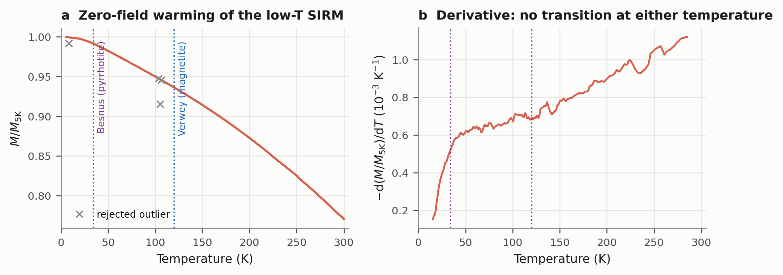
Figure 3. Low-temperature behaviour of the thin film. (a) Moment on zero-field warming from 5 to 300 K, normalised to its 5 K value; dotted lines mark the Verwey transition of magnetite and the Besnus transition of monoclinic pyrrhotite, and crosses are rejected instrument dropouts. (b) The derivative, showing no feature at either temperature. The smooth 23 % loss is the progressive unpinning behaviour reported for pseudo-single-domain and multidomain greigite.
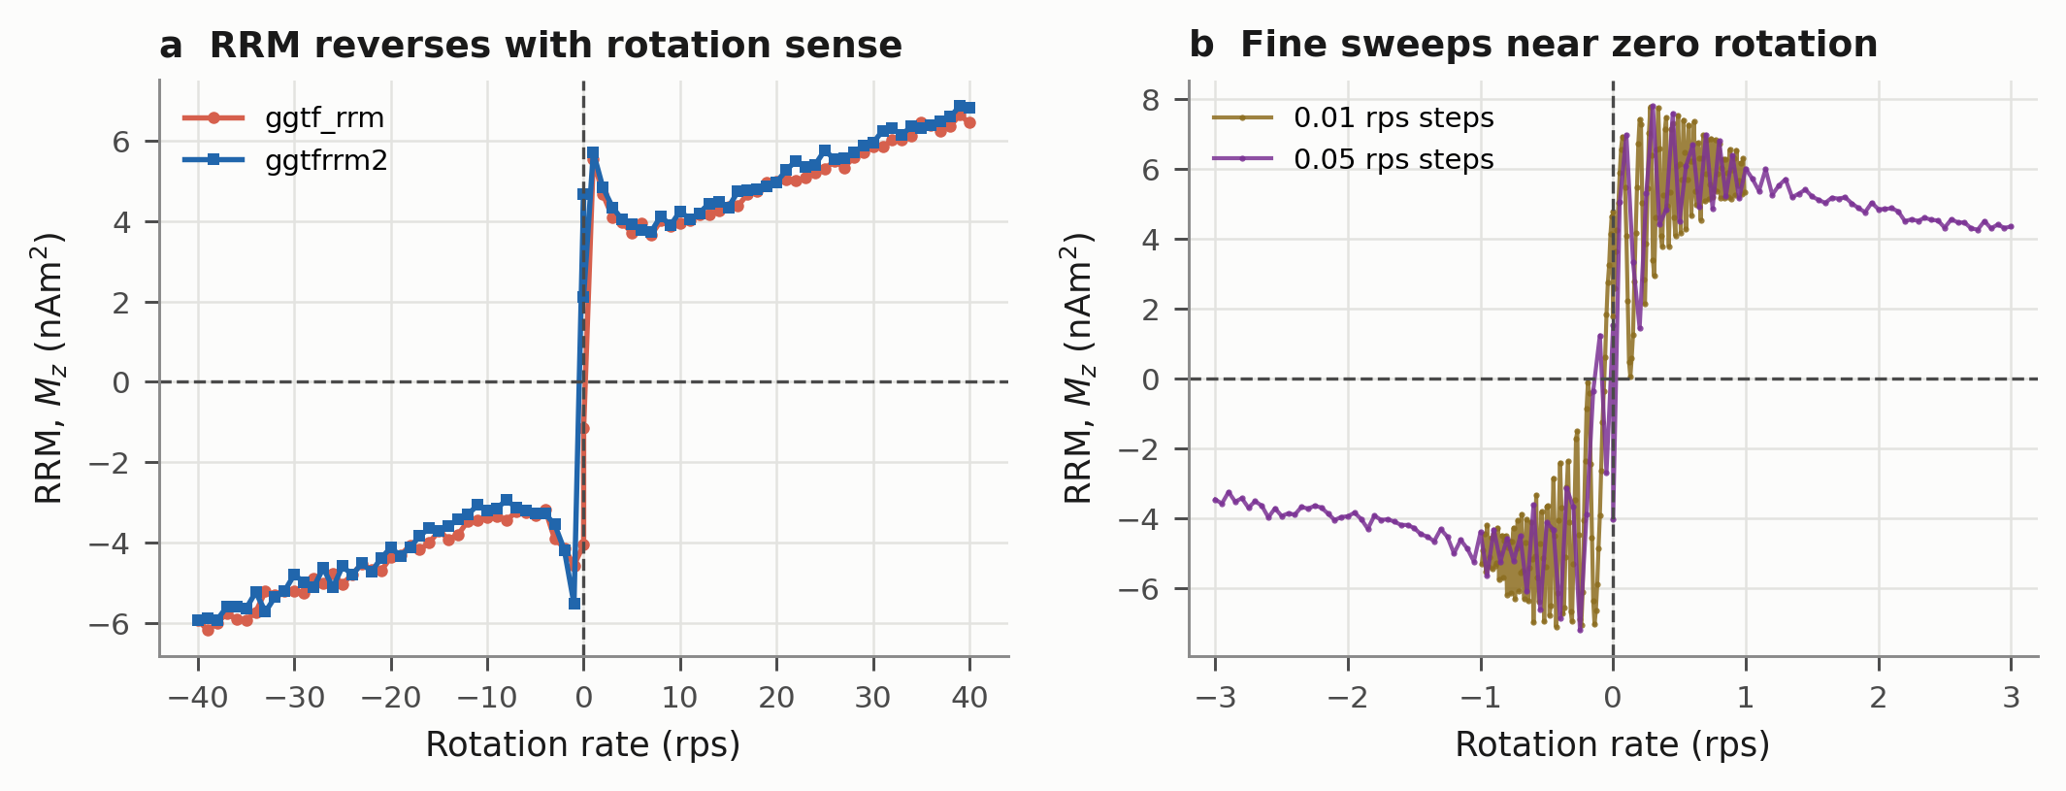
Figure 4. Rotational remanent magnetisation of the thin film at a 94 mT peak alternating field. (a) Two coarse sweeps through both senses of rotation; the moment reverses sign with the sense of rotation, which is the defining test of the Stephenson effect, and the two runs superimpose. (b) Fine sweeps near zero rotation rate, where the moment left by starting and stopping the rotation is comparable to the moment acquired during steady rotation and the measurement is not usable.
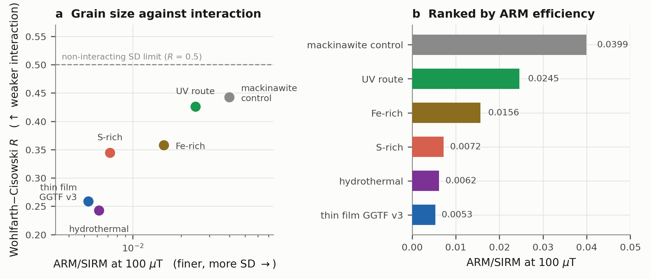
Figure 5. The two mass-independent measures, which are the only valid cross-specimen comparisons given that masses were not recorded. (a) ARM/SIRM against the Wohlfarth–Cisowski R parameter. The two respond to different physics — grain size and magnetostatic interaction — yet order the specimens almost identically. (b) The same ARM/SIRM values ranked. Of the three prebiotic routes the UV preparation gives the finest and least interacting material; the non-prebiotic hydrothermal benchmark gives the coarsest and most interacting.

Appendix A. Abbreviations and notation
Every abbreviation used in this document.
Abbr. | Stands for | Abbr. | Stands for
AF | alternating field | MPMS | Magnetic Property Measurement System
ARM | anhysteretic remanent magnetisation | NRM | natural remanent magnetisation
CISS | chiral-induced spin selectivity | Oe | oersted; 1 mT = 10 Oe
DC | direct current (a steady, non-alternating field) | PSD | pseudo-single-domain (vortex)
DCD | direct-current demagnetisation — the backfield curve | RAO | ribose-aminooxazoline
DP | dispersion parameter | remFORC | remanence first-order reversal curve
emu | electromagnetic unit; 1 emu = 10⁻³ Am² | rps | revolutions per second
FORC | first-order reversal curve | RRM | rotational remanent magnetisation
FTO | fluorine-doped tin oxide (the substrate) | SD | single domain
GRM | gyroremanent magnetisation | SF | smoothing factor
IRM | isothermal remanent magnetisation | SIRM | saturation isothermal remanent magnetisation
MAF | median acquisition field | SP | superparamagnetic
MD | multidomain | SQUID | superconducting quantum interference device
MDF | median destructive field | VSM | vibrating-sample magnetometer

A.1 Symbols
Every symbol used in this document, with what it means rather than only what it is called. Fields are written as flux densities in millitesla throughout; much of the rock magnetic literature uses oersted instead, where 1 mT = 10 Oe. Moments are in Am²; instrument files often report emu, where 1 emu = 10⁻³ Am².
Symbol | Name | What it means | In this study
Magnetisations and remanences
M | magnetisation / moment | How strongly the specimen is magnetised, measured as a magnetic moment. An extensive quantity: it scales with how much material is in the holder, so moments are only comparable between specimens when masses are known. | Am² (1 emu = 10⁻³ Am²)
M_{s} | saturation magnetisation | The moment when every magnetic domain has been forced to align by a large applied field. Measured in field, so it cannot be obtained from the 2G. | 8.73 µAm² (film)
M_{rs} | saturation remanence | What is left after the saturating field is switched off. The magnetisation that persists with no field — the quantity that matters for surface templating. | 3.33 µAm² (film)
NRM | natural remanent magnetisation | The remanence the specimen already carried when it arrived, before any laboratory field was applied. | checked, not interpreted
IRM | isothermal remanent magnetisation | Remanence left after applying and removing a steady field at room temperature. Imparted by a pulse here. | stepped to 973 mT
SIRM | saturation IRM | The IRM once further field adds nothing more — the largest remanence the specimen can hold. | 0.16–10 µAm²
ARM | anhysteretic remanent magnetisation | Remanence acquired in a decaying alternating field with a small steady bias superposed. Fine single-domain grains acquire it efficiently; coarse multidomain grains barely do. | 100 mT peak AF, 0–1 mT bias
RRM | rotational remanent magnetisation | Remanence acquired by rotating the specimen in an alternating field. Reverses sign when the rotation reverses — a signature no axial experiment can imitate. | 6.6–7.8 nAm² (film)
Fields and coercivities
B | magnetic field | Written as a flux density throughout. Older rock magnetic literature uses H in oersted; 1 mT = 10 Oe. | mT
B_{c} | coercivity | The reverse field needed to bring the magnetisation of the whole specimen to zero while the field is still applied. A property of the hysteresis loop. NOTE: the same symbol labels the horizontal FORC axis, where it means something related but distinct — see below. | 18.9 mT (film)
B_{cr} | coercivity of remanence | The reverse field which, once removed, leaves zero remanence. Always larger than B_{c}, because some grains that were turned while the field was on spring back when it is removed. This is the coercivity a remanence-only instrument can measure. | 30–70 mT
H_{r} | reversal field | The negative field a FORC curve starts from. Each reversal curve has one. | −2.5 to −200 mT
H_{b} | measurement field | The field swept upward from H_{r} during a reversal curve; the moment is recorded at each value. | to +180 mT
MDF | median destructive field | The peak alternating field that destroys half a given remanence. A stability measure: higher means the remanence is more firmly held. Quoted separately for the IRM and the ARM. | 26–50 mT
MAF | median acquisition field | The field at which half the saturation remanence has been acquired, read off the IRM acquisition curve. | 32–110 mT
FORC quantities
ρ(B_{c}, B_{u}) | FORC distribution | The mixed second derivative of magnetisation with respect to the reversal and measurement fields. Read as a joint probability distribution: how many particles in the specimen have a given switching field and a given local bias field. | normalised to its own peak
B_{c} (FORC axis) | switching field | Horizontal axis of a FORC diagram, (H_{b} − H_{r})/2. The field an individual particle needs to flip — set by its size, shape and crystal anisotropy. An energy-barrier axis: high B_{c} means a magnetisation that resists reversal. | peak at 20–50 mT
B_{u} (FORC axis) | interaction / bias field | Vertical axis, (H_{b} + H_{r})/2. The field a particle feels from its magnetic neighbours. Narrow spread means particles act independently; wide spread means they are magnetostatically coupled. | spread ±10 to ±40 mT
SF | smoothing factor | Size of the neighbourhood used to fit the local polynomial when computing ρ. Larger values give a smoother diagram at the cost of resolution. | 3
Ratios and shape parameters
M_{rs}/M_{s} | squareness | What fraction of the forced alignment survives when the field is removed. 0.5 for randomly oriented, non-interacting single-domain particles; falls towards 0.05 and below as grains coarsen into multidomain. | 0.381 (film)
B_{cr}/B_{c} | coercivity ratio | How much harder it is to erase a remanence than to zero the in-field magnetisation. 1.09 at the single-domain limit, rising above 4 for multidomain. Plotted against M_{rs}/M_{s} on a Day diagram. | 2.35 or 1.49 — see §7
ARM/SIRM | ARM efficiency | A grain-size proxy. High values mean fine single-domain material, low values coarse multidomain. A ratio of two remanences on the same specimen, so it does not need the specimen mass. | 0.0053–0.0399
χ_{ARM} | ARM susceptibility | The slope of ARM against the bias field that produced it, fitted over all bias steps rather than taken from one. | 2.1 × 10⁻⁴ Am²/T
R | Wohlfarth–Cisowski parameter | The normalised remanence where the acquisition and demagnetisation curves cross. 0.5 if particles do not interact magnetically; lower values mean stronger interaction between neighbours. | 0.243–0.443
S₋₃₀₀ | S-ratio | What fraction of the saturation remanence is carried by low-coercivity minerals, judged at 300 mT. Near 1 means a soft phase such as magnetite or greigite carries essentially everything. | 0.973–1.008
DP | dispersion parameter | The width of the coercivity distribution in log field units. Small means one tight population of grain sizes; large means a broad mixture. | 0.264–0.326
Domain states
SP | superparamagnetic | Particles small enough that thermal energy flips them spontaneously within seconds. They magnetise strongly in a field but hold no remanence at all, so they cannot template anything. | excluded by remFORC
SD | single domain | One uniform magnetic moment across the whole particle, so the surface presents a single spin direction. The state the CISS argument requires. | dominant in all six
PSD / vortex | pseudo-single-domain | Intermediate sizes where the moment curls into a vortex. Flux closes internally and the net external and surface moment is much reduced. | film and benchmark trend here
MD | multidomain | Large particles divided into domains whose moments largely cancel. Low remanence and low coercivity. | not observed
Mineral diagnostics
Verwey transition | ≈120 K | A crystallographic and magnetic transition in magnetite, seen as a step in remanence on warming. Its absence argues against magnetite. | absent
Besnus transition | ≈34 K | The equivalent transition in monoclinic pyrrhotite. Its absence argues against pyrrhotite. | absent
CISS | chiral-induced spin selectivity | The effect by which electron transfer through a chiral molecule is spin-dependent, so a spin-polarised surface favours one enantiomer over the other. The reason the magnetism matters to the chemistry. | the mechanism under test
One symbol carries two meanings and the difference matters. On a hysteresis loop, B_{c} is the coercivity of the whole specimen — the reverse field that zeroes its in-field magnetisation. On a FORC diagram, the horizontal axis is also labelled B_{c}, but there it is the switching field of an individual particle. The loop value is a weighted average over the distribution the FORC axis resolves, so the two are related but are not the same number, and the FORC peak does not in general sit at the loop coercivity.

References
Carvallo, C., Dunlop, D. J. and Özdemir, Ö. (2005). Experimental comparison of FORC and remanent Preisach diagrams. Geophysical Journal International 162, 747–754. doi:10.1111/j.1365-246X.2005.02688.x
Chang, L., Roberts, A. P., Rowan, C. J., Tang, Y., Pruner, P., Chen, Q. and Horng, C.-S. (2009). Low-temperature magnetic properties of greigite (Fe₃S₄). Geochemistry, Geophysics, Geosystems 10. doi:10.1029/2008GC002276
Cisowski, S. (1981). Interacting vs. non-interacting single domain behavior in natural and synthetic samples. Physics of the Earth and Planetary Interiors 26, 56–62.
Day, R., Fuller, M. and Schmidt, V. A. (1977). Hysteresis properties of titanomagnetites: grain-size and compositional dependence. Physics of the Earth and Planetary Interiors 13, 260–267.
Hu, S., Stephenson, A. and Appel, E. (2002). A study of gyroremanent magnetisation (GRM) and rotational remanent magnetisation (RRM) carried by greigite from lake sediments. Geophysical Journal International 151, 469–474. doi:10.1046/j.1365-246X.2002.01793.x
Pike, C. R., Roberts, A. P. and Verosub, K. L. (1999). Characterizing interactions in fine magnetic particle systems using first order reversal curves. Journal of Applied Physics 85, 6660–6667.
Roberts, A. P., Pike, C. R. and Verosub, K. L. (2000). First-order reversal curve diagrams: a new tool for characterizing the magnetic properties of natural samples. Journal of Geophysical Research 105, 28461–28475.
Snowball, I. F. (1997). Gyroremanent magnetization and the magnetic properties of greigite-bearing clays in southern Sweden. Geophysical Journal International 129, 624–636.
Wohlfarth, E. P. (1958). Relations between different modes of acquisition of the remanent magnetization of ferromagnetic particles. Journal of Applied Physics 29, 595–596.
Zhao, X., Roberts, A. P., Heslop, D., Paterson, G. A., Li, Y. and Li, J. (2017). Magnetic domain state diagnosis using hysteresis reversal curves. Journal of Geophysical Research: Solid Earth 122, 4767–4789. doi:10.1002/2016JB013683

